 | 12.1.52 Editors - Geometry Nodes Editor - Header - Add Menu - Hair - Write
Table of content
Detailed table of content 1
Add menu - Hair - Utility 1
Set Hair Curve Profile 2

Detailed table of content
Detailed table of content
Detailed table of content 1
Add menu - Hair - Utility 1
Set Hair Curve Profile 2
Input 2
Geometry 2
Replace Radius 2
Radius 2
Shape 2
Factor Min 2
Factor Max 2
Output 2
Geometry 2

Add menu - Hair - Utility

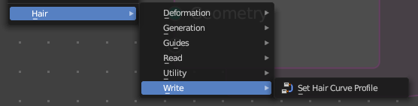
Hair nodes are Node Groups found in the Essentials Library included with Bforartists. They differ from the other nodes in the add menu due to being mid level node groups instead of individual low level nodes.
You can enter the node tree by clicking at the icon up right. Tab to leave the node tree. And you can of course also edit the node tree.



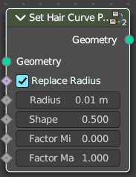
Set Hair Curve Profile
Set the radius attribute of hair curces according to a profile shape.

Input

Geometry
The input geometry.

Replace Radius
Replace the original radius.

Radius
Base radius to be set when replace radius is enabled.

Shape
Shape of the radius along the curve.

Factor Min
Factor of the radius at the minimum.

Factor Max
Factor of the radius at the maximum.

Output

Geometry
The output geometry.

